Intro to HTML

#### **How would the browser know that you are using the HTML5 version?**



#### **Which tag tells the browser where the HTML page starts and stops?**

<html>

#### **The latest HTML standard is -**



#### **What can be the possible extension for the HTML5 file?**



#### **The BODY tag is usually used after -**



#### **How do we write comments in HTML5?**



#### **The title tag -**

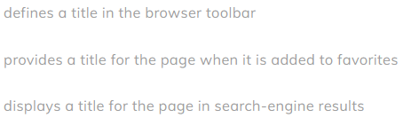

#### **Where is the title tag defined?**



#### **Using <p> tag will -**



#### **Can the element <h1> be replaced with <H1>?**



#### **Correct HTML tag for the largest heading -**

<h1>

#### **We can use Title Tag instead of using H1 tag to show Heading.**



#### **What does the <br> tag add to your webpage?**



#### **What is the difference between an HTML tag and an HTML element?**



#### **To create a bulleted list, use -**



#### **To start a list using filled circles, use -**



#### **What kind of list will <ol> tags create?**



#### **Which tag will display the content of list?**

Li

#### **Which attribute is/are used to set the dimensions of the image?**

Width height

#### **Which attribute is used to set the path for an image element?**

src

**<img> tag has no closing tag.**

True

#### **If the image cannot be displayed then ___ attribute specifies an alternate text for an image.**

alt

#### 

#### **The tag used for creating hypertext and hypermedia links is**

<a>

#### **URL for link is specified using ___ attribute.**

href

#### **A linked page using anchor tag is normally displayed in -**

Same tab

#### **Which attribute is used to specify where to open the linked document?**

target

#### **Default color of active link in browser is -**

red

#### **Relative URLs are used to -**



#### **For defining internal links in a page we use -**

id

#### **A home.html file is present in a folder named “pages”. The “pages” folder is present in the same folder as the index.html file. You wish to add a link in the index file that links to home.html. How will you do it?**



#### **In HTML, tags that include both start and end tag are called**



#### **What is the correct syntax for writing ‘doctype’ in HTML5?**

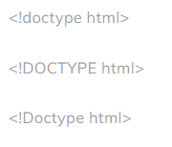

#### **Alt Attribute is more useful in the situation where user have**

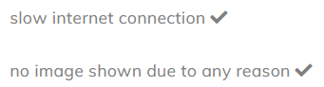

#### **What tag is used to list individual items of an ordered list?**

li

#### **To start a list at the count of 3, use -**



#### **Link in HTML can be of following type(s) -**

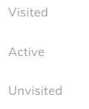

#### **Default style and color of unvisited link in any browser is -**

#### **Which of the following is used to open document in new window / Tab ?**



#### **To create a link to an email address, which of the following syntax is used?**



#### **Which of the following will show an image located in folder named ‘image’, which is in the parent folder of the current page?**



#### **HTML <dl> tag defines the**



#### **Which tag is used to describe a term/name in a description list?**

<dd>

#### **Dimensions of an image should be preferably specified in % instead of a pure number. Comment. (multiple answers correct)**

